DUCLAIRON WISHES THE CHURCH A HAPPY THANKSGIVING 2016
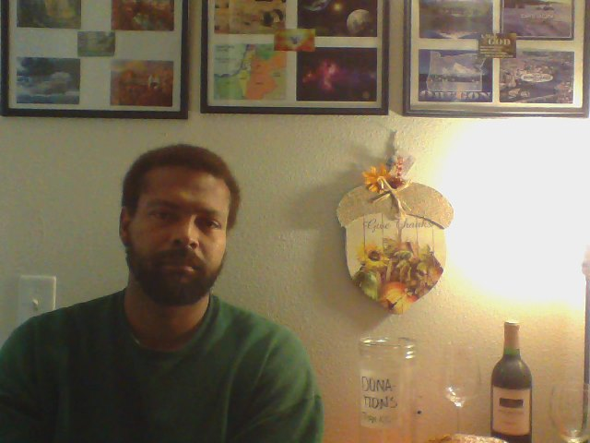
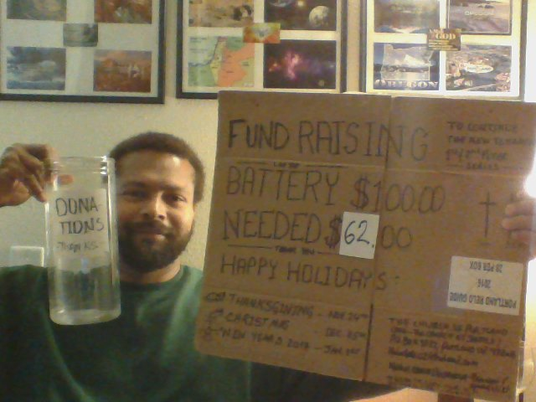
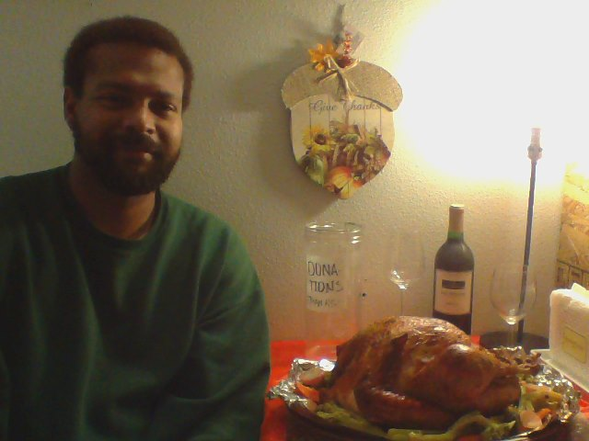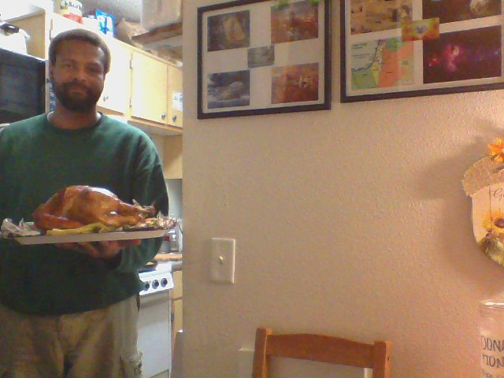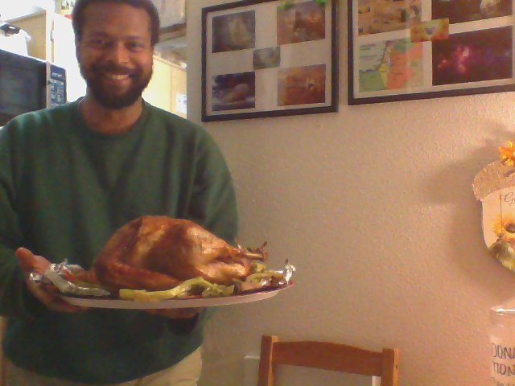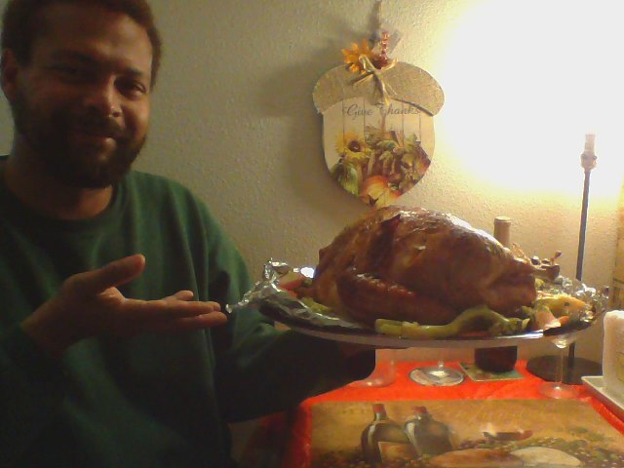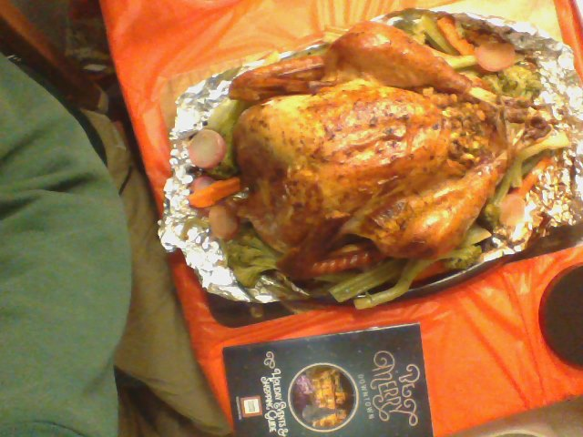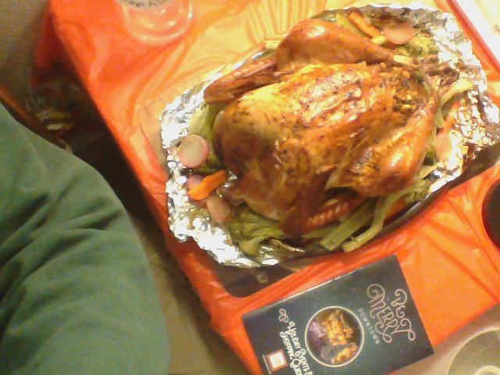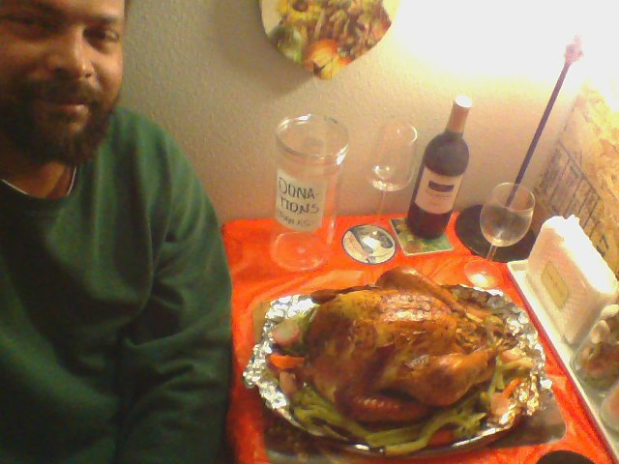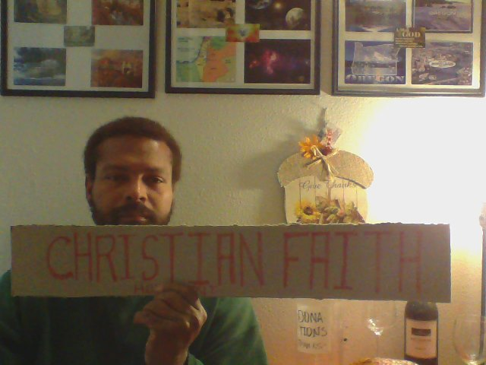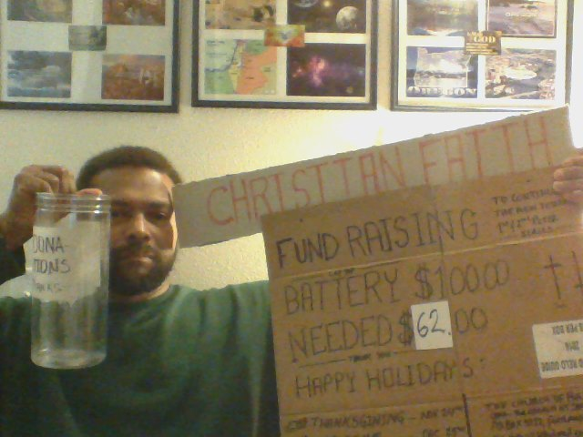
HOW DID YOU SPEND YOUR THANKSGIVING? WERE YOU WITH FRIENDS, FAMILY OR DID YOU VISIT RELATIVES? THOSE OF US WHO ARE STILL SINGLE LIKE THAT PERSONAL TIME OF JUST REFLECTING ON THE PAST YEAR AND ALL THAT GOD HAS DONE. I HOPE YOURS WAS ONE OF THOSE TIMES.
HAVE A HAPPY HOLIDAYS

